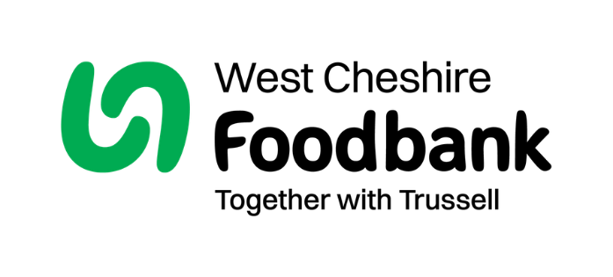
Our vision is for a future without the need for
West Cheshire food bank.
Our values:

Our values are at the heart of everything we do, helping all the food bank sessions in our area navigate tough decisions and support communities effectively. We are based on Christian principles, whilst also being accessible and meaningful for people, whatever their background, gender, religion, or ethnicity.



Compassion: Motivates us to stand alongside people in crisis and provide support and care for individuals.
Justice: It is not right that somebody should experience hunger or poverty. This drives us to take action to change this so that everyone can afford the essentials.
Community: As people, we are all interconnected, and because of this, we have a responsibility to support each other. To create change, we must work together for a fairer society.
Dignity: We recognise the value of each individual person, prioritising the other person’s needs and concerns in the spirit of friendship.

Our mission: Working in partnership to bring our communities together to end food insecurity in West Cheshire. We plan to do this in three main ways:

1.Changing communities: We are working with referral partner and others in the local community, including our volunteers to unlock the potential for our meeting places and other operational locations to become places where the underlying drivers of acute poverty are addressed.



2.Changing policy: We are gathering data and campaigning locally and nationally to drive policy change to ensure that no one needs to use a foodbank.


3.Changing minds: Lasting change happens when wider society thinks and acts differently about an issue, so we’re building understanding and empathy about the drivers of food bank use, to build a movement that is willing to take action to create a just and compassionate society without the need for food banks.

